Ten Seconds Game

By Trung Le (Kyle Hunter)

# Concept (who, what, when, where, why, how)

You have 10 seconds to kill enemy robots. If you can’t kill them in time, 2 more will be spawned in their place. In addition, randomly spawned enemy robots will appear randomly in the level to chase you.

# Objective:

Try to survive for as long as you can. Enemies will only drop ammo.

# Core System

* 2 main scenes: StartScene and GameplayScene
* Industry-standard Third Person Shooter:

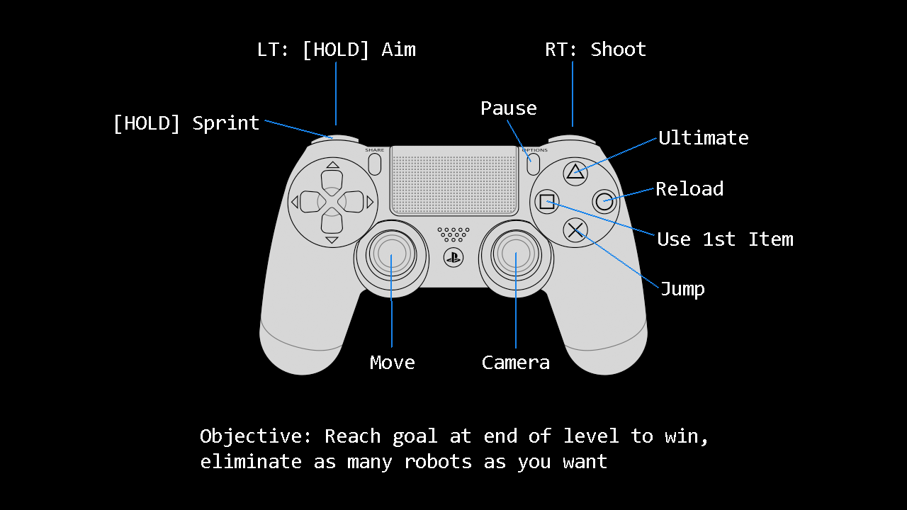

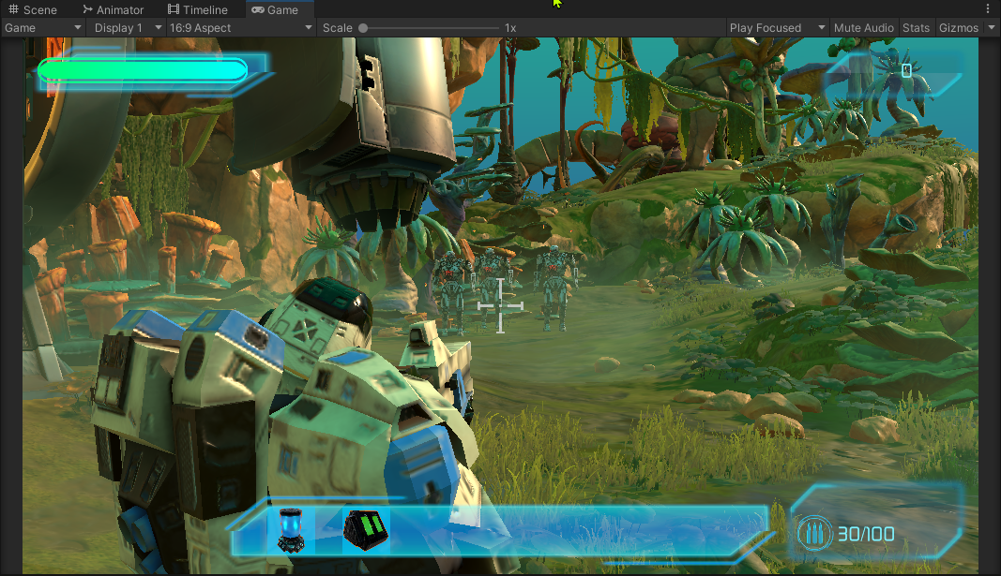

* Double Jump

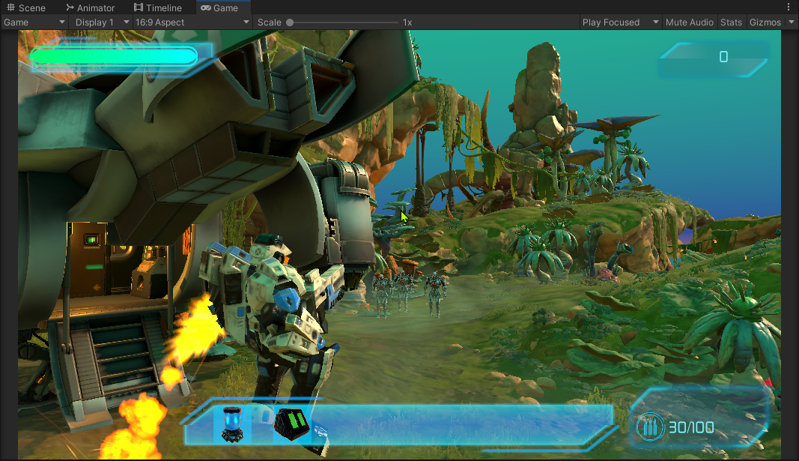

* Ultimate ability:

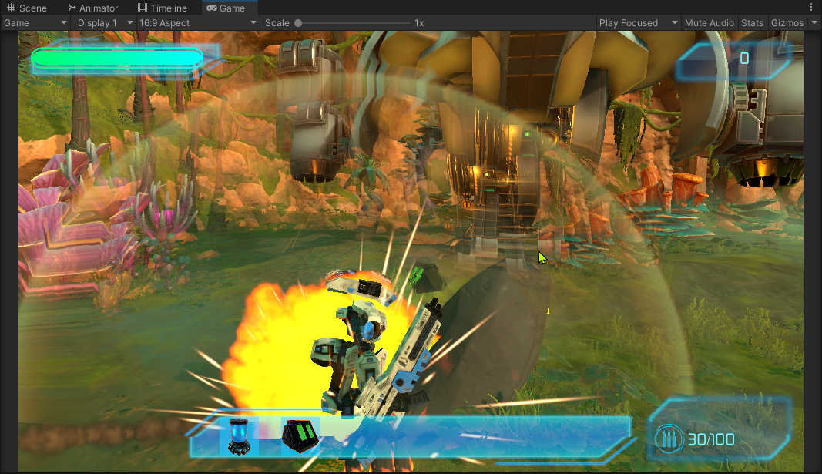

* Ragdoll physics:

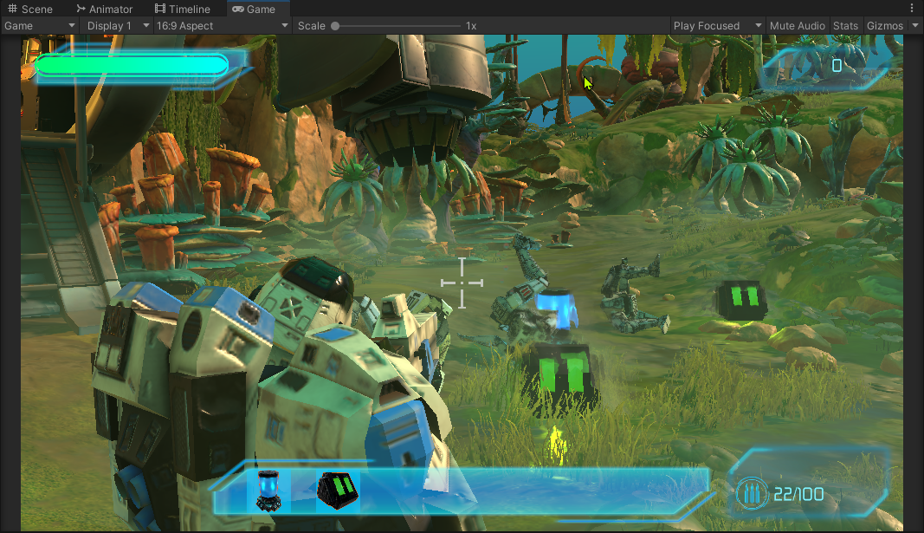

* Enemies
  + Standard Robot: will either chase or shoot you

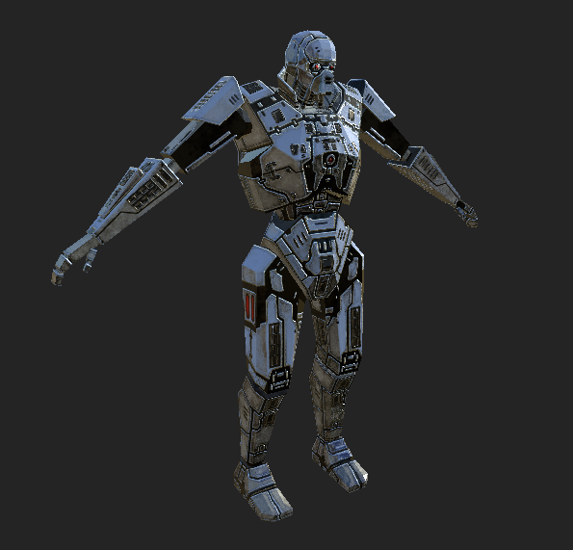

* + Will drop potion or ammo when dead:



* + Will be spawned randomly in level and will chase you:

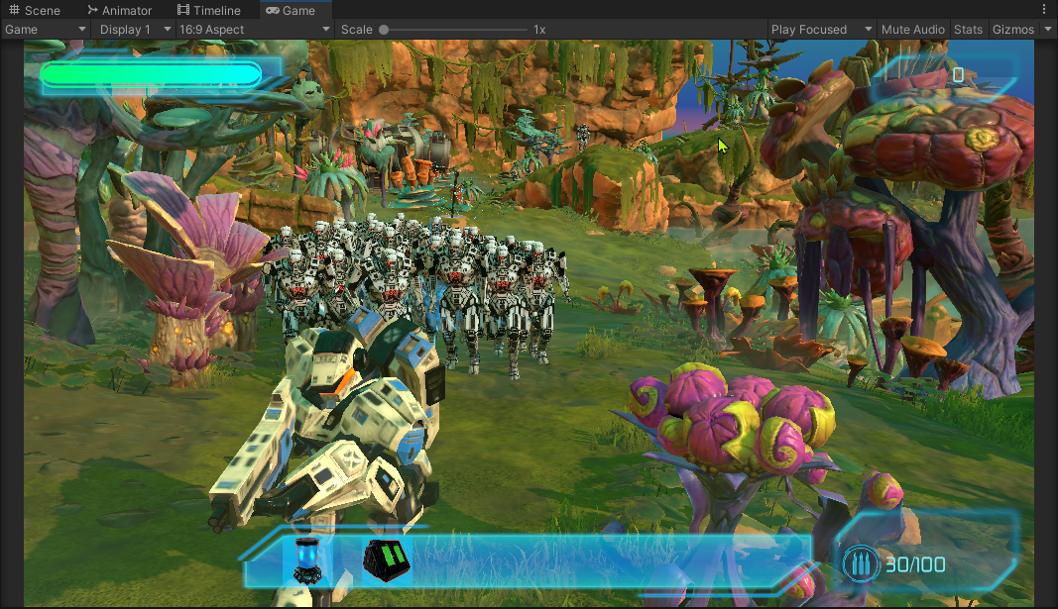

* Damage: Shoot or use ultimate ability to damage enemies.
* Killcount: killcount increases when enemy despawns.

# Supporting System

* Inventory: The player can pick up ammo, then press a button to use the 1st one as a consumable. Ammo will be restored to max. If you have more than 7 items then the pickup will be destroyed. NO POTION DROP.

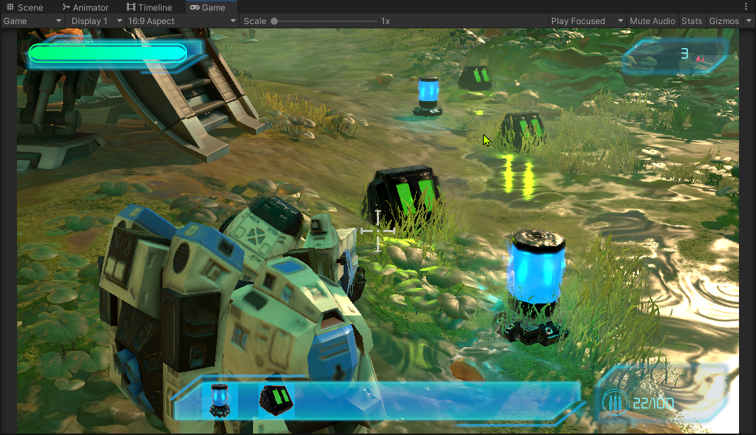

# Save System

What will be saved:

* Equipped weapon/ammo
* Current health
* Current player position
* Current kill count

# Menu

* Main Menu
* Tutorial screen
* Pause menu
* Game Over screen

# Sounds

* Randomized sounds for various effects

# Effects

* Almost everywhere.